**Name -: Aditya Babaso Birangaddi**

**Roll No -: 47**

**Enrollment No -: 1915770160**

**Practical No 7**

**Sample Questions -:**

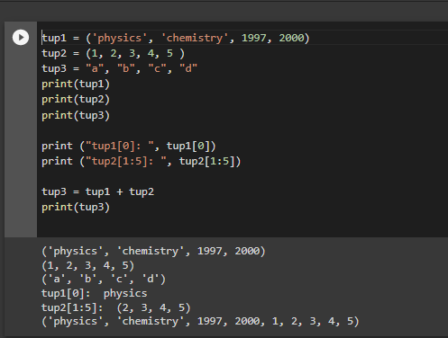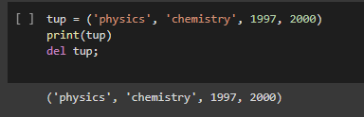

**1. Create a tuple and find the minimum and maximum number from it.**

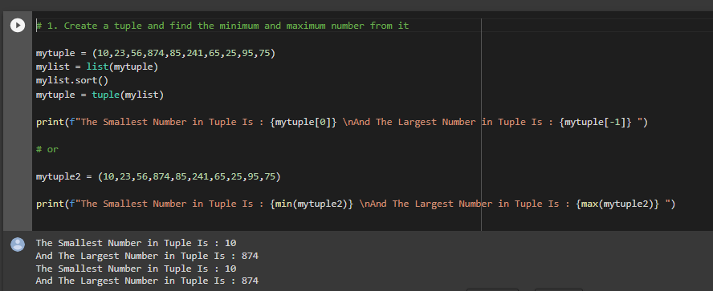

**2. Write a Python program to find the repeated items of a tuple.**

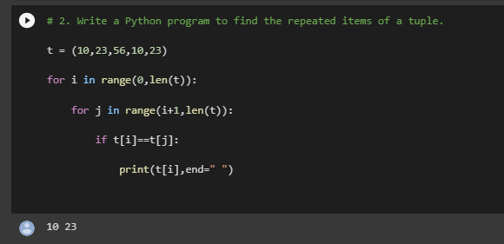

**3. Print the number in words for Example: 1234 => One Two Three Four**

